**Project – SQL (Business Case Study)**

**1. Import the dataset and do usual exploratory analysis steps like checking the structure & characteristics of the dataset:**

1.1 Data type of all columns in the "customers" table.

Result -

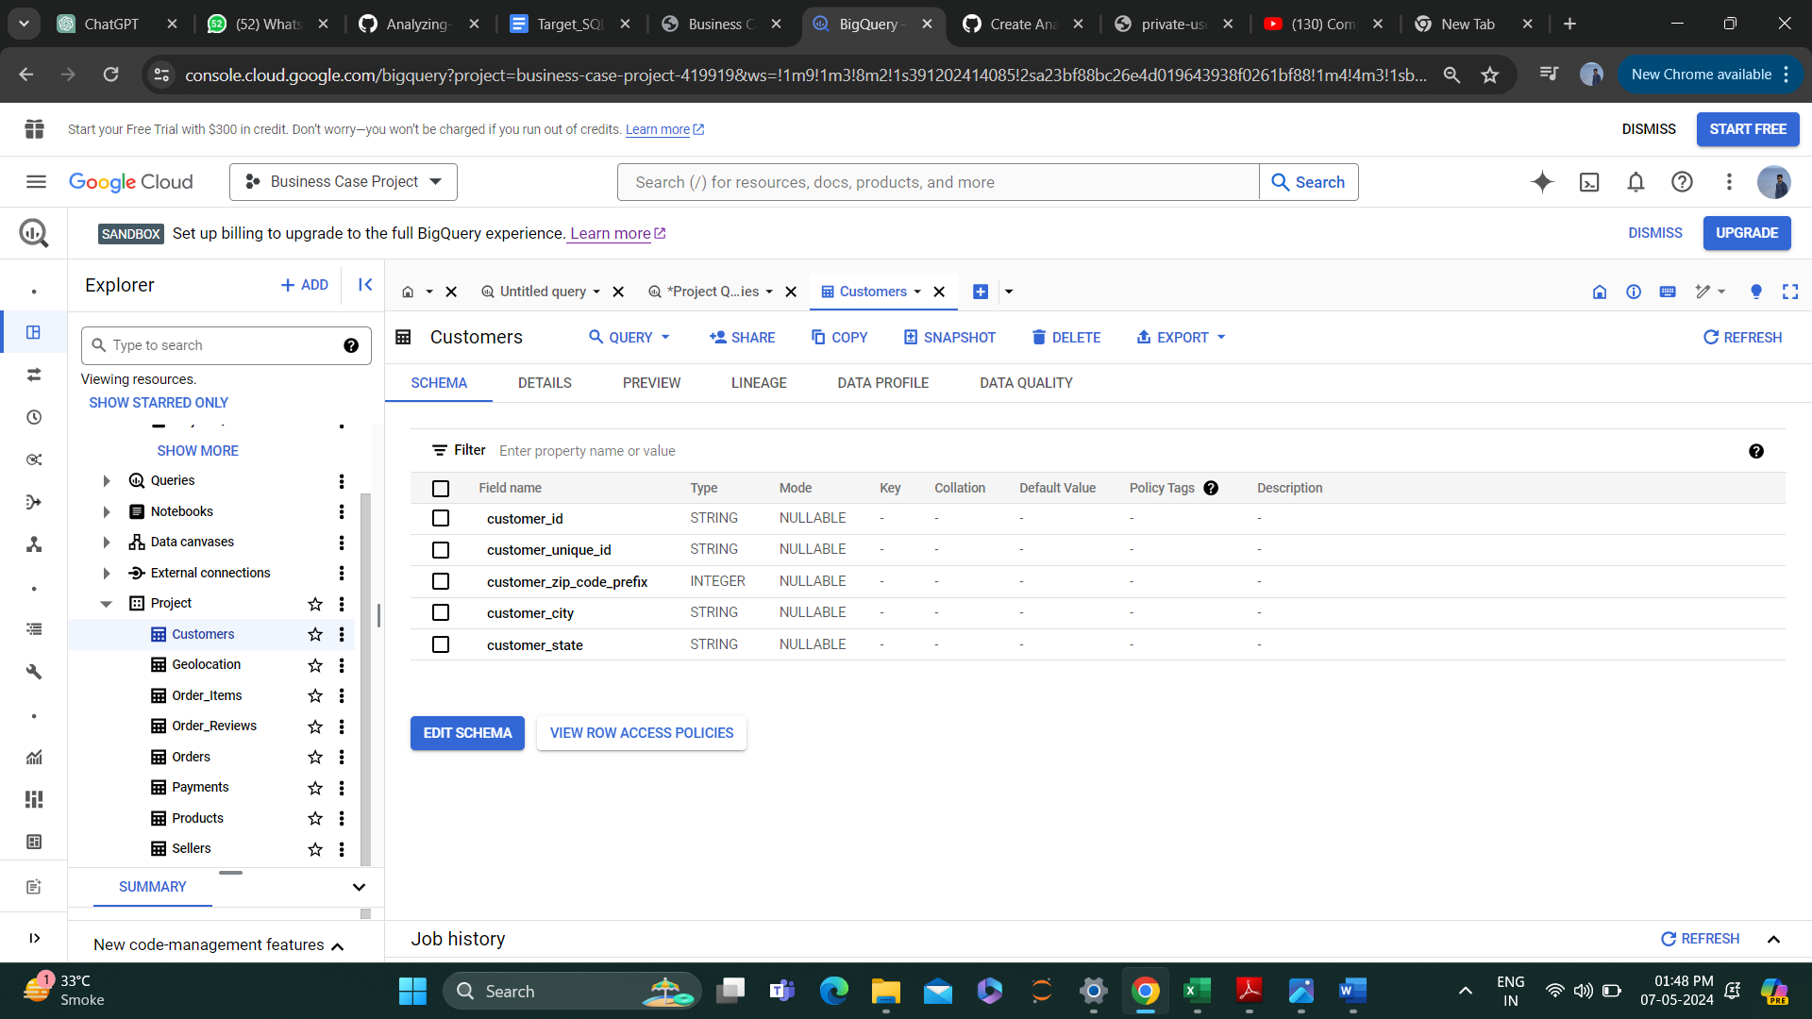

1.2. Get the time range between which the orders were placed.

Query -

select

min (order_purchase_timestamp) as start_time_of_order_placement,

max (order_purchase_timestamp) as End_time_of_order_placement

from `Project.Orders`

Result –

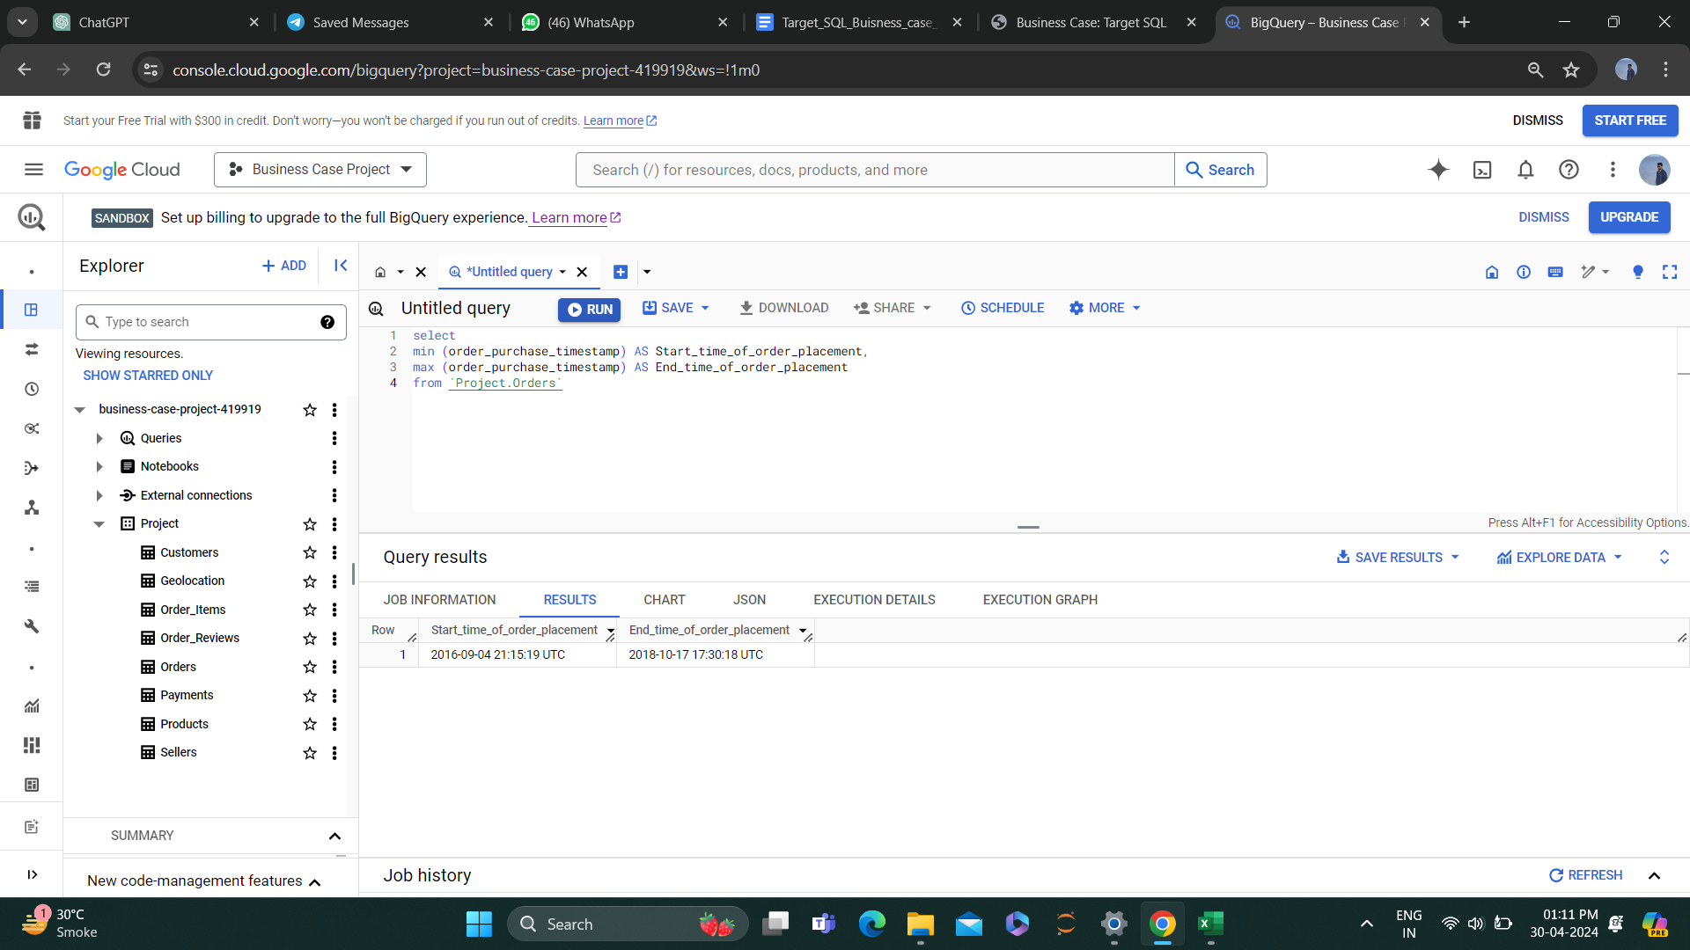

1.3. Count the Cities & States of customers who ordered during the given period.

Cities –

select

count(distinct geolocation_city) as Cities

from `Project.Geolocation`;

Result –

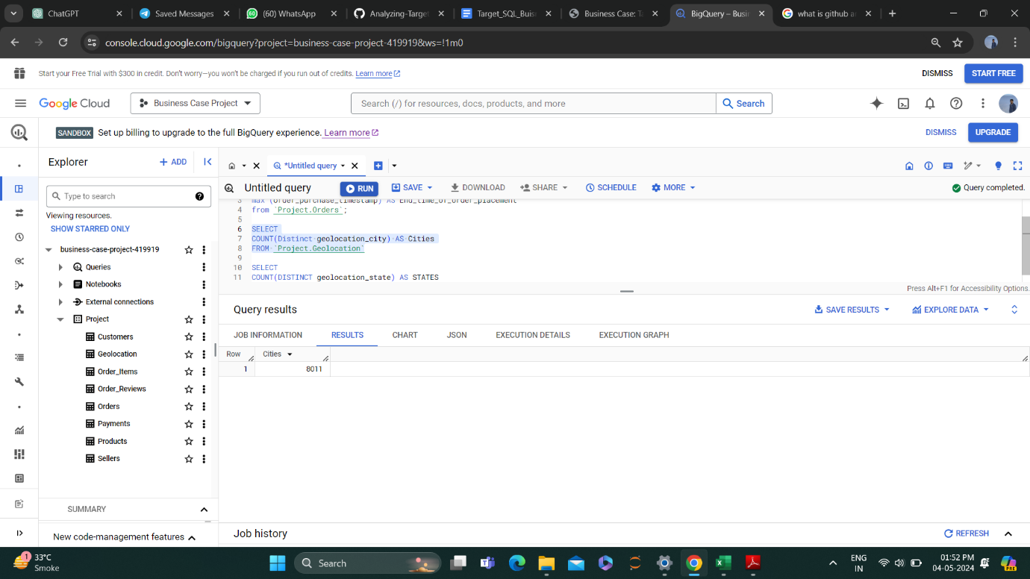

States –

select

count(distinct geolocation_state) as states

from `Project.Geolocation`;

Result –

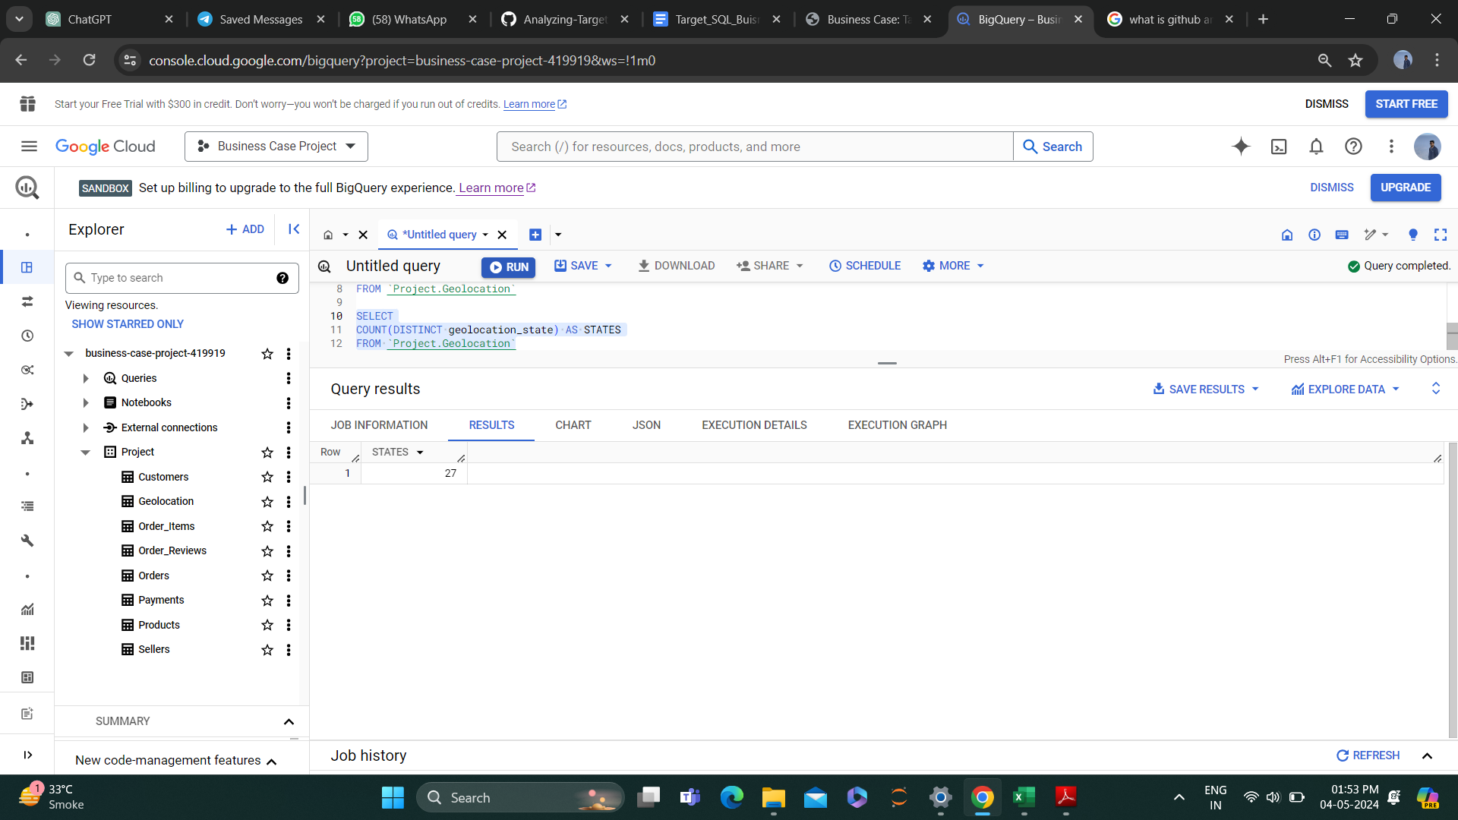

**2. In-depth Exploration:**

2.1. Is there a growing trend in the no. of orders placed over the past years?

2.2. Can we see some kind of monthly seasonality in terms of the no. of orders being placed?

Query –

select

count (Distinct order_id) as Total_orders,

Extract (Month from order_purchase_timestamp) as Month,

Extract (Year from order_purchase_timestamp) as Year

from `Project.Orders`

Group by Month, Year

Order by Year, Month ASC;

Result –

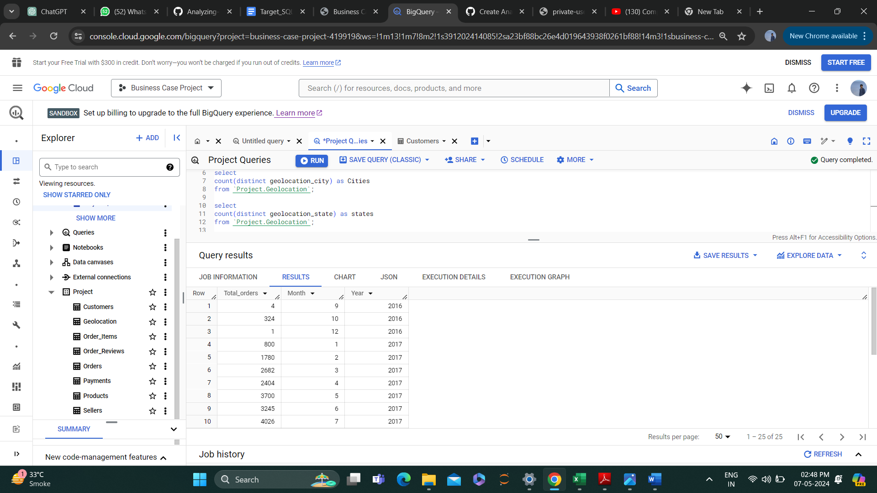 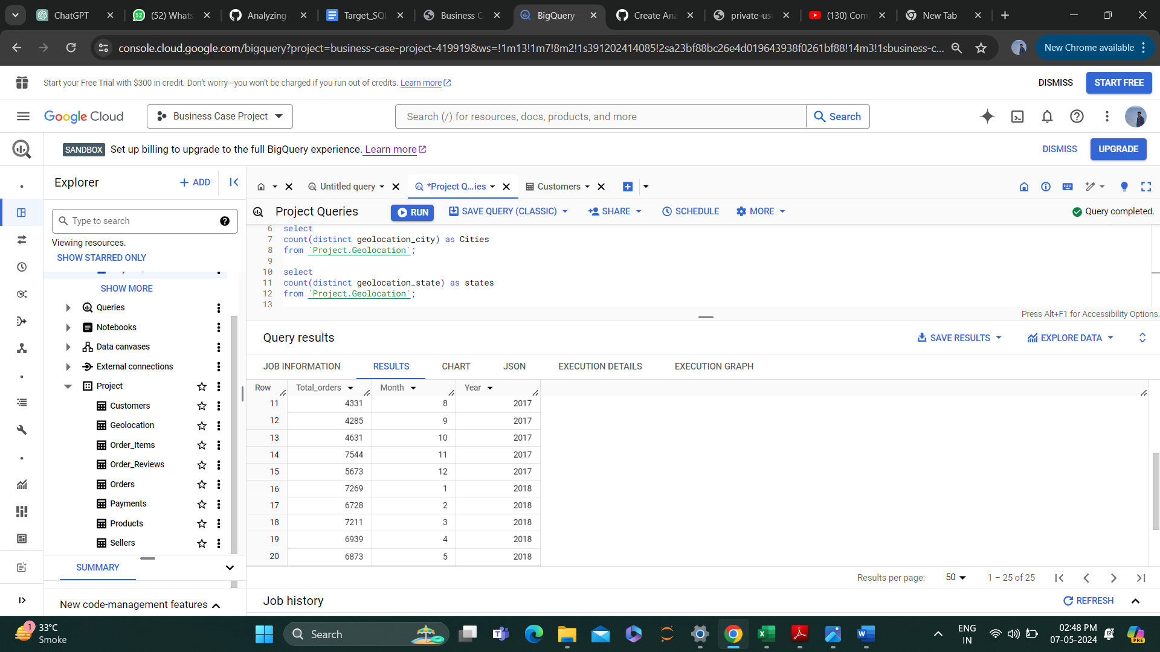

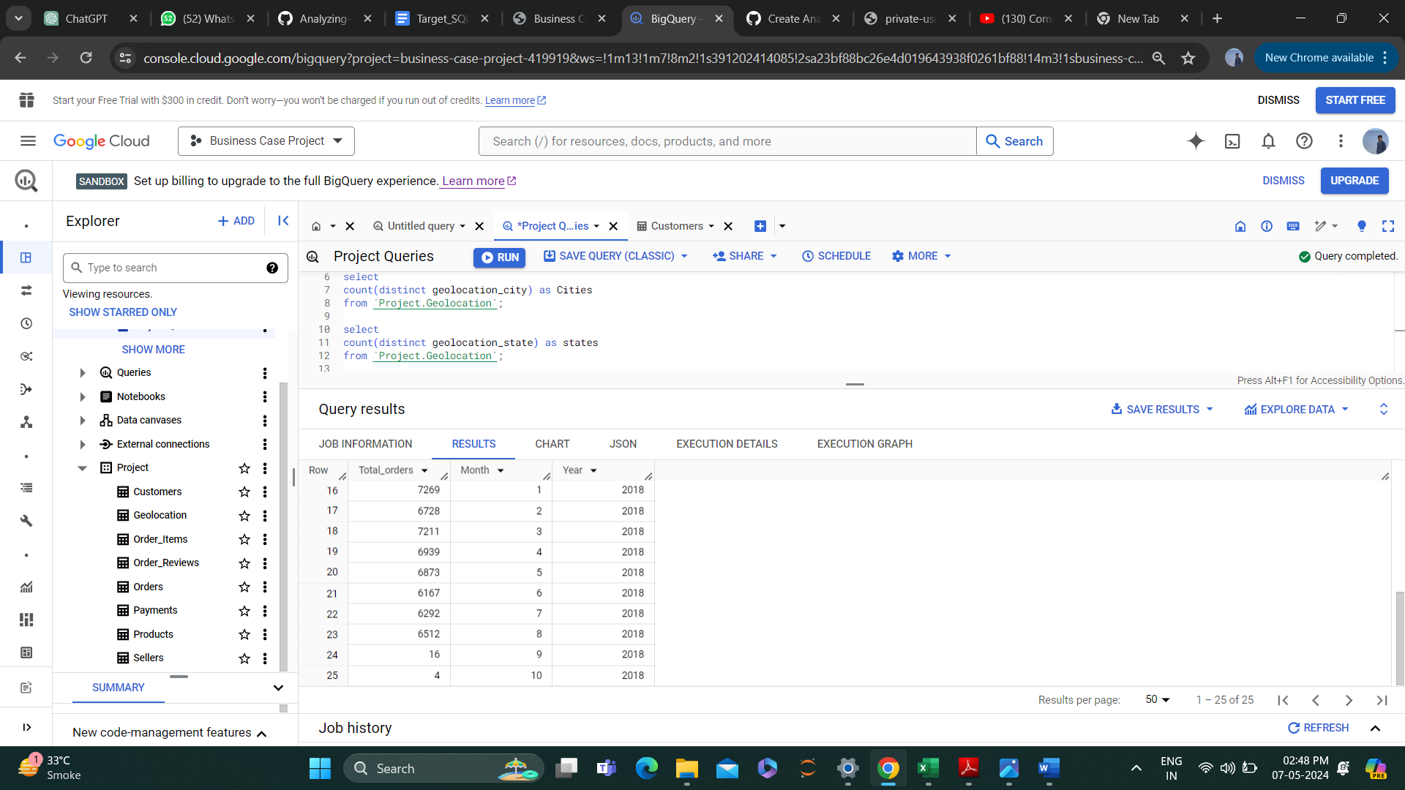

Insights - Yes, there is a growing trend in e-commerce in Brazil. From the end of 2016 to the end of 2018 (except the 9th and 10th month of 2017) there was an increase in unique Order ID’s.

Regarding seasonality, there are some peaks at speciﬁc months in Brazil. In February 2017 & November 2017 we can see peak in orders signiﬁcantly.

Recommendation- There was a speciﬁc event or promotion that caused an increase in demand in Feb & Nov 2017.. The business should investigate the cause of this spike and try to replicate it in the future.

2.3. During what time of the day, do the Brazilian customers mostly place their orders?

(Dawn, Morning, Afternoon or Night)

Query –

select

Buying_time,

count(Buying_time) as Count_of_Buying

from

(select

order_purchase_timestamp,

case

when Hour_field < 5 and mins_field between 0 and 59 then "Dawn"

when Hour_field between 6 and 11 and mins_field between 0 and 59 then "Morning"

when Hour_field between 12 and 17 and mins_field between 0 and 59 then "Afternoon"

Else "Night"

END as Buying_time FROM

(SELECT

order_purchase_timestamp,

EXTRACT(HOUR FROM order_purchase_timestamp) AS HOUR_FIELD,

EXTRACT(MINUTE FROM order_purchase_timestamp) AS MINS_FIELD,

EXTRACT(SECOND FROM order_purchase_timestamp) AS SECS_FIELD FROM

`Project.Orders`))

Group By Buying_time

Result –

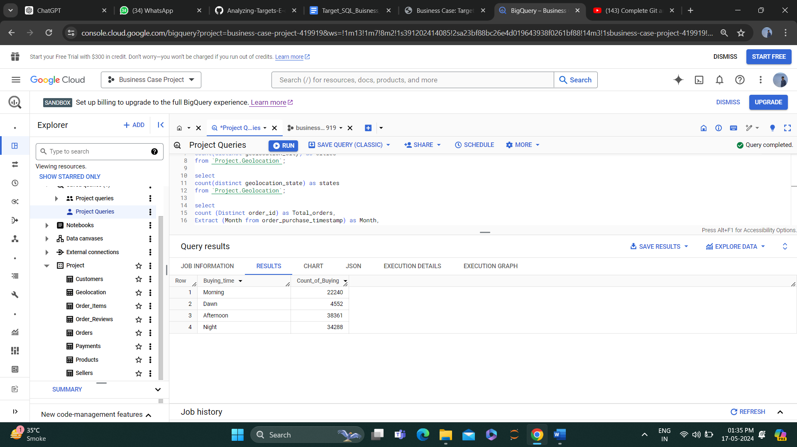

Insights - Afternoon purchases had the highest count of 38,361, followed by night purchases with a count of 34288. Morning purchases had the lowest count with 22,240.

Additionally there were only 4552 purchases made during Dawn time, indicating this may not be the popular time for the customers to make purchase.

Recommendation: Consider offering promotions and discounts during the Dawn hours, to promote more sales during those hours.

**3. Evolution of E-commerce orders in the Brazil region:**

3.1. Get the month on month no. of orders placed in each state.

Query –

SELECT

customer_state,

count(distinct(order_id)) as Customer_count, Month,

Year FROM (SELECT

  o.customer_id,

  t.customer_state,

  o.order_id,

  EXTRACT(Month from order_purchase_timestamp) As Month,

  EXTRACT(Year from order_purchase_timestamp) As Year FROM `Project.Orders` AS o

LEFT JOIN `Project.Customers` AS t ON o.customer_id = t.customer_id) GROUP BY customer_state, Month, Year

ORDER BY customer_state, Year,Month

Result –

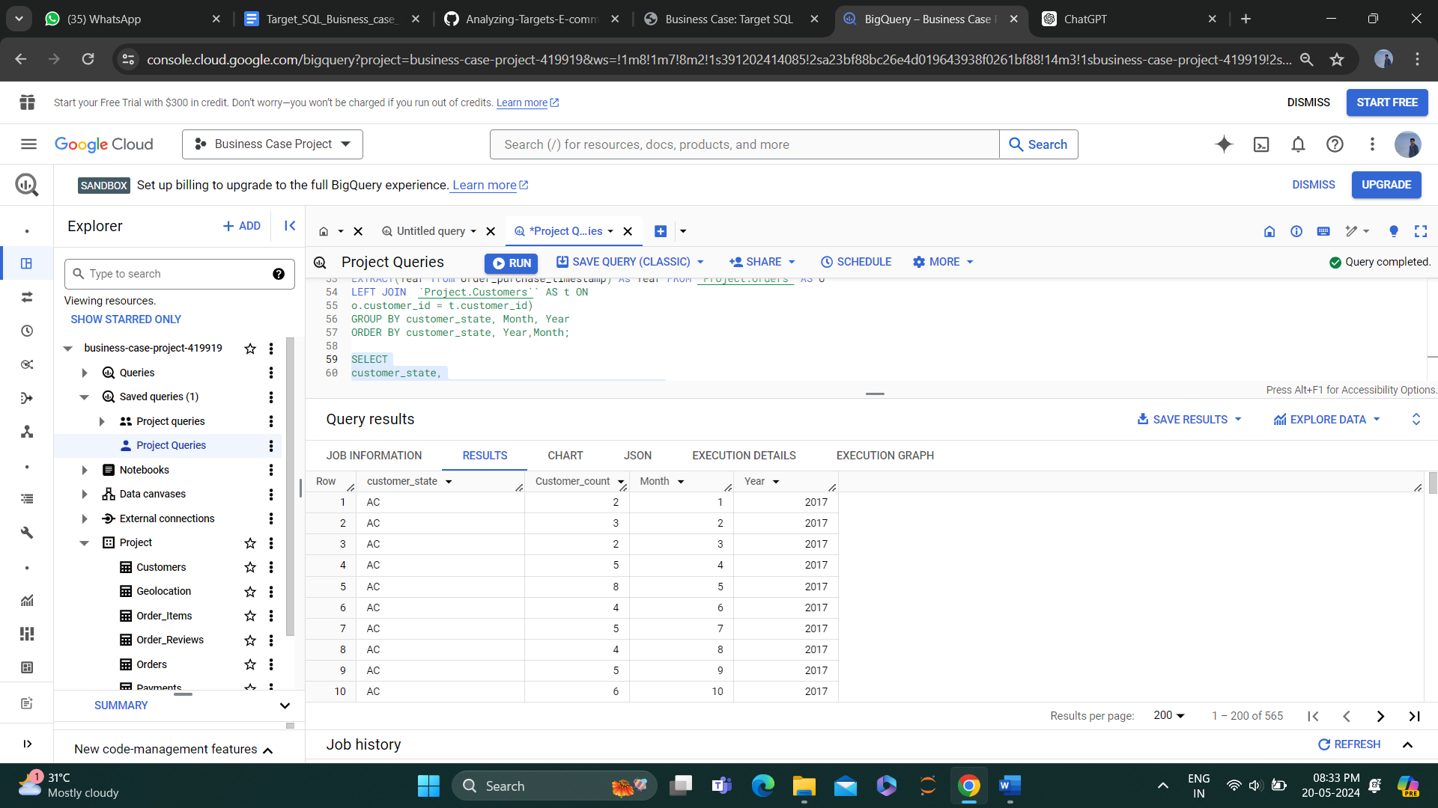 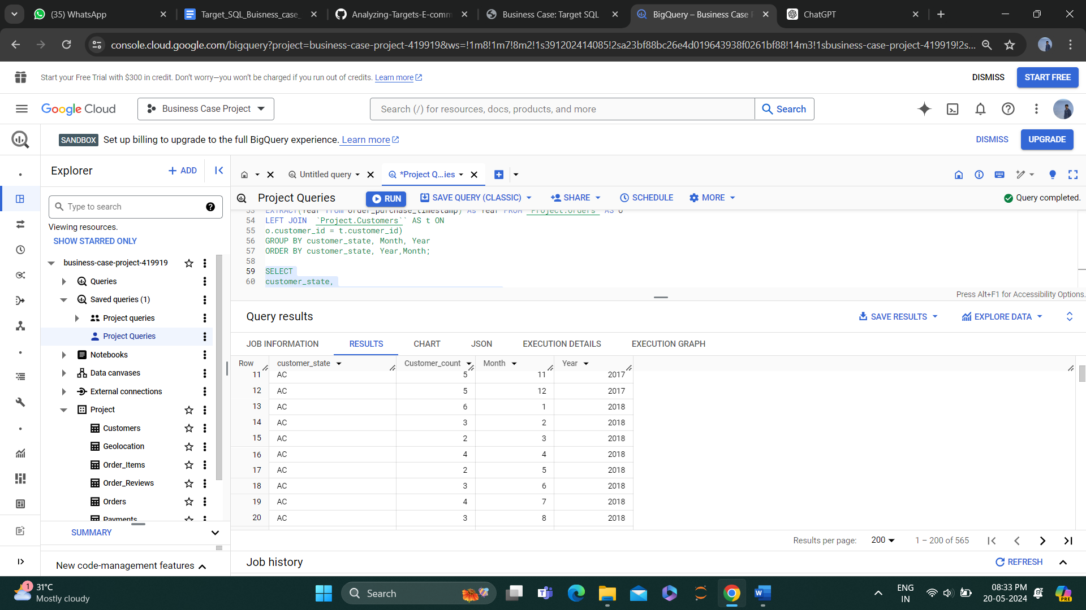

3.2. How are the customers distributed across all the states?

Query –

select

customer_state,

count(distinct(customer_id)) as Customer_count

 from `Project.Customers`

 group by customer_state

 order by customer_count

 DESC

Result –

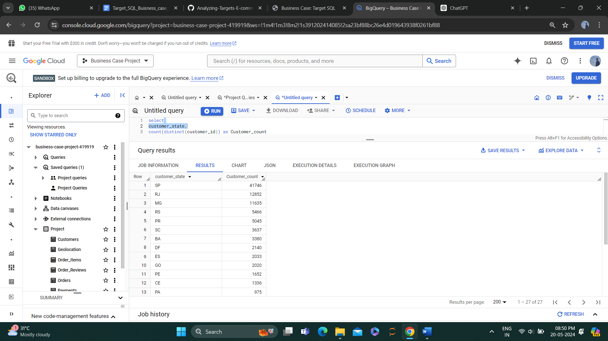 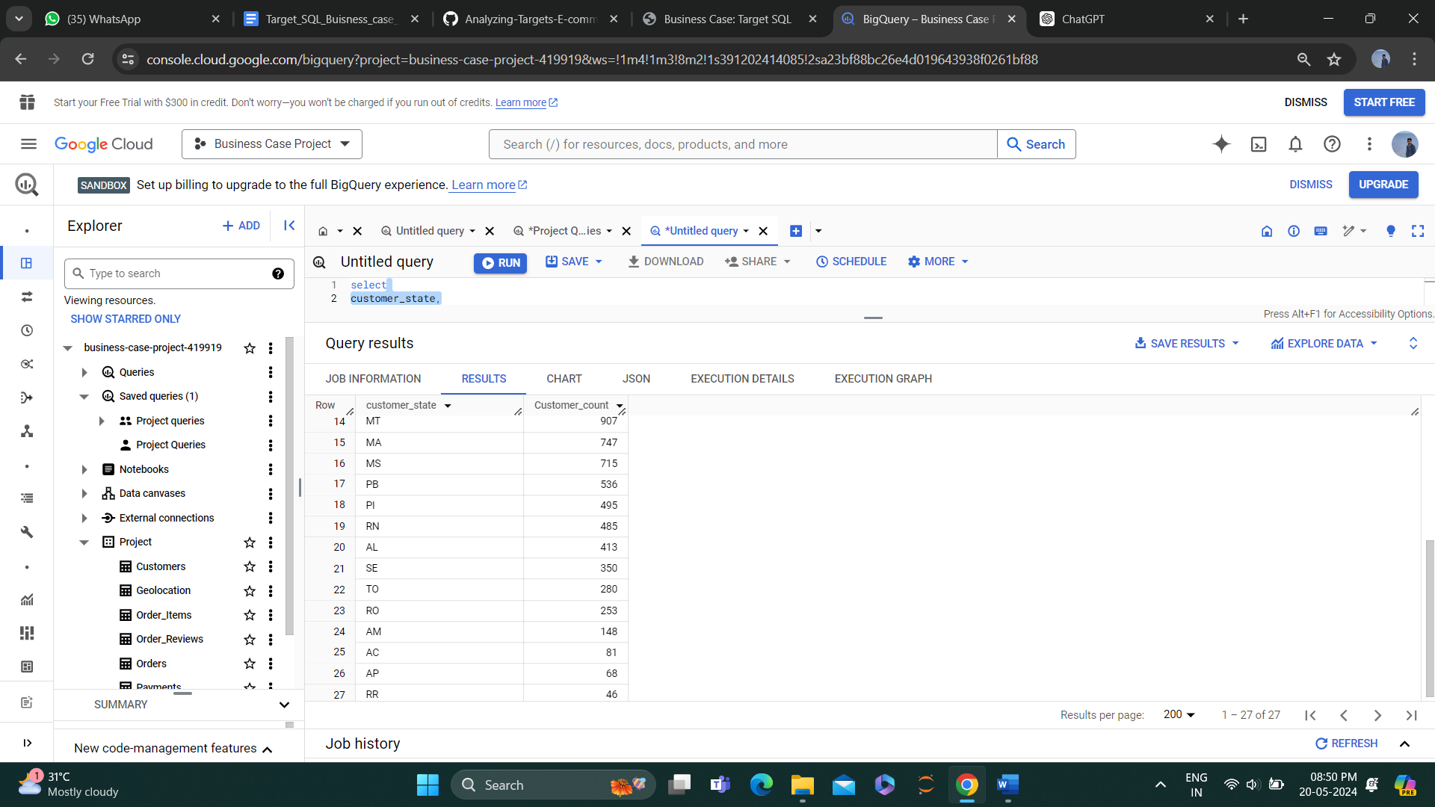

Insights - São Paulo (SP) has the highest number of customers with a count of 41,746, Rio de Janeiro (RJ) has the second highest with 12,852 customers and Minas Gerais (MG) is the third with 11,635 customers.

In Total 27 states, the top 12 states have more than 1000 customers. 13th to 24th have customers of more than 100 but less than 1000.

The bottom 3 states have less than 100 customers.

Recommendation-Focus on retaining customers in states with high customer counts by offering promotions, discounts, or loyalty programs to incentivize repeat purchases.

-For states with low customer counts, consider targeted marketing campaigns to

acquire new customers, such as social media advertising, inﬂuencer partnerships, or referral programs.

**4. Impact on Economy: Analyze the money movement by e-commerce by looking at order prices, freight and others.**

4.1. Get the % increase in the cost of orders from year 2017 to 2018 (include months between Jan to Aug only).

Query –

With Base as (select

EXTRACT(Year from order_purchase_timestamp) As Year, Sum(payment_value)as revenue

From `Project.Orders` as t

inner join `Project.Payments`as p on t.order_id = p.order_id

where EXTRACT(Month from order_purchase_timestamp) between 1 and 8 GROUP BY Year),

base2 as (Select *, Lag(revenue) over (order by Year)as previous_revenue from base )

SELECT *, (revenue-previous_revenue)/previous_revenue*100 as per_INC from base2

Result –

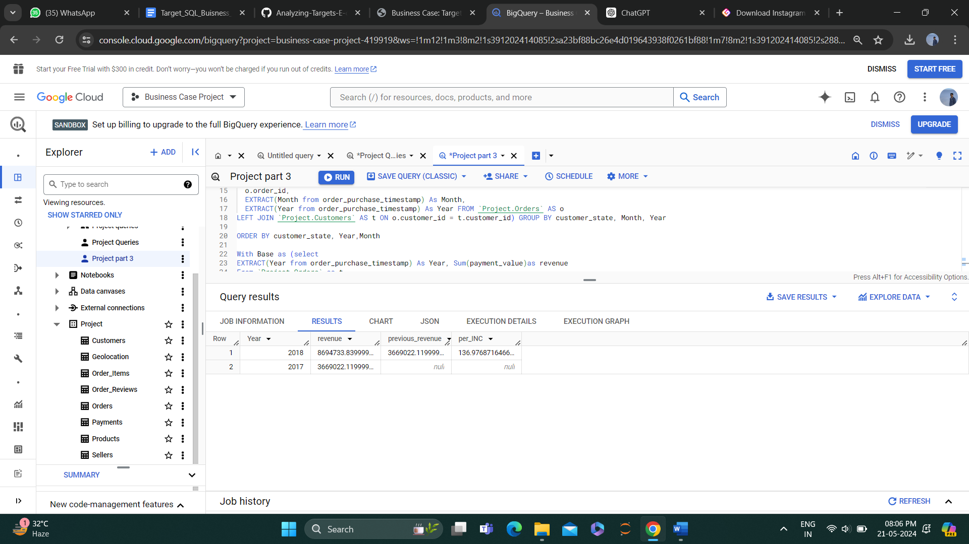

Insights - The revenue in 2018 is signiﬁcantly higher than in 2017, with a year-over-year increase of 136.98%.

Recommendation - Use the revenue data to inform budgeting and resource allocation decisions, such as increasing investments in marketing or expanding product offerings in high-growth areas.

4.2. Calculate the Total & Average value of order price and order frieght for each state.

Query –

SELECT

customer_state,

SUM(price) AS Price_Sum,

SUM(freight_value) AS Freight_Sum,

AVG(price) AS Avg_Price,

AVG(freight_value) AS Avg_Freight FROM

`Project.Order_Items` AS items INNER JOIN

`Project.Orders` AS o ON

items.order_id = o.order_id INNER JOIN

`Project.Customers` AS c ON

o.customer_id = c.customer_id GROUP BY

customer_state Order by price_sum

Result –

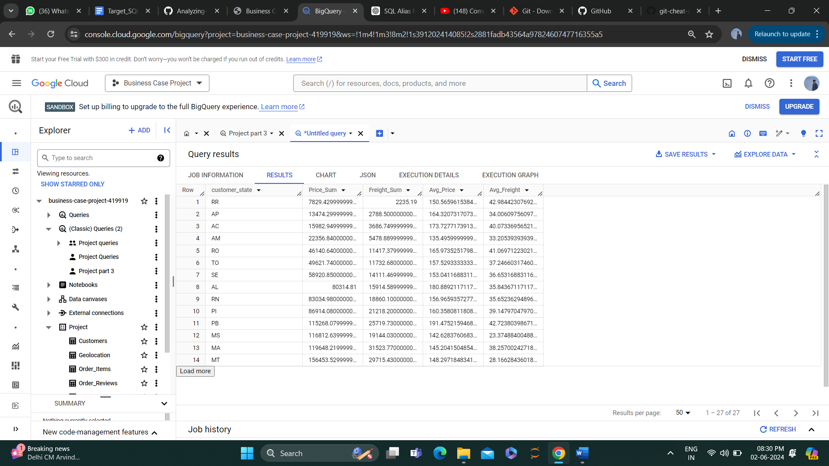 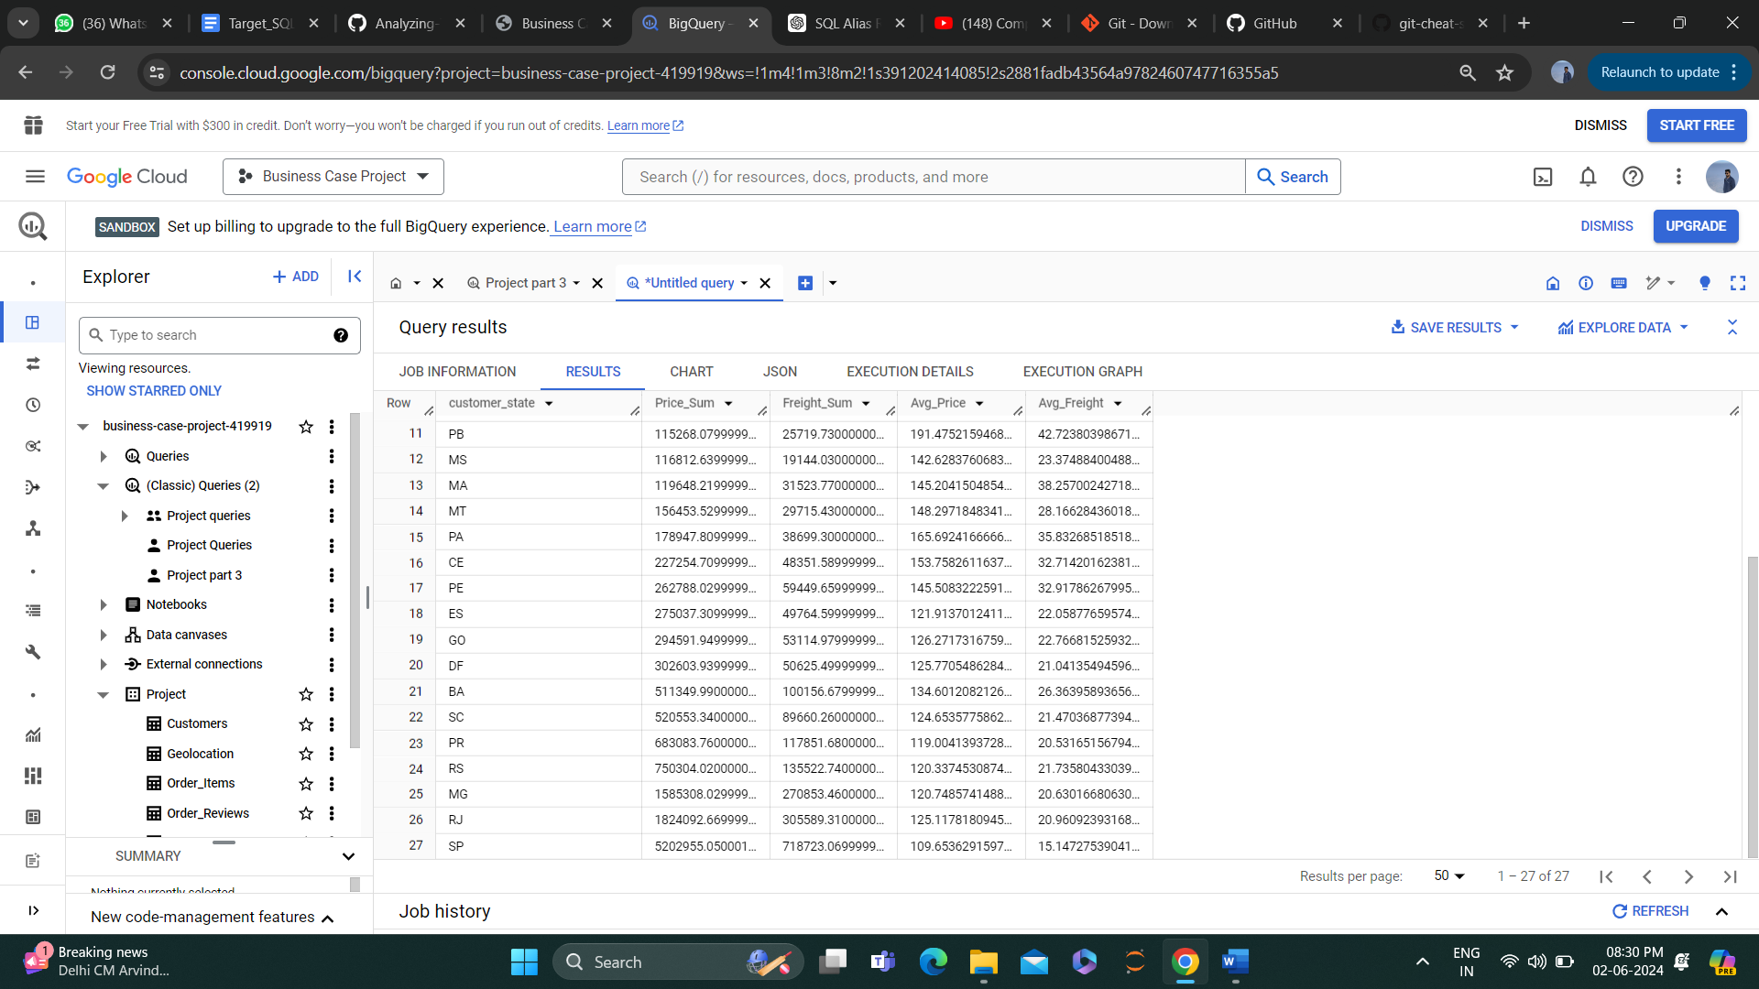

Insights –

* The highest total price sum is from the state of Sao Paulo (SP) , which is more than twice the price sum of the second highest state, Rio de Janerio (RJ).
* The highest average price is also from the state of Sao Paulo(SP), indicating that customers from this state tend to purchase higher proced items.
* The lowest total price sum is from the state of Espirito Santo (ES).
* The highest total freight sum is from the state of Minas Gerais (MG), followed by Sao Paulo (SP) and Rio de Janerio (RJ).
* The highest average freight is from the state of Bahia (BA).

Recommendations – The state with highest average prices and freight value may be good targets for marketing campaigns for higher end products, while those with lower values may be better suited for more affordable products.

**5. Analysis based on sales, freight and delivery time.**

5.1 Calculate days between purchasing, delivering and estimated delivery

Query –

SELECT

  order_purchase_timestamp,

  order_estimated_delivery_date,

  order_delivered_customer_date,

  estimated_day,

  Delivery_time,

     (estimated_day-Delivery_time) AS buffer_day FROM (

     SELECT

  order_purchase_timestamp,

  order_estimated_delivery_date,

  DATE_DIFF(order_estimated_delivery_date, order_purchase_timestamp, DAY) AS estimated_day,

  order_delivered_customer_date,

  DATE_DIFF(order_delivered_customer_date, order_purchase_timestamp, DAY) AS Delivery_time

       FROM

  `Project.Orders`

     WHERE

  order_delivered_customer_date IS NOT NULL)

  order by buffer_day

Result –

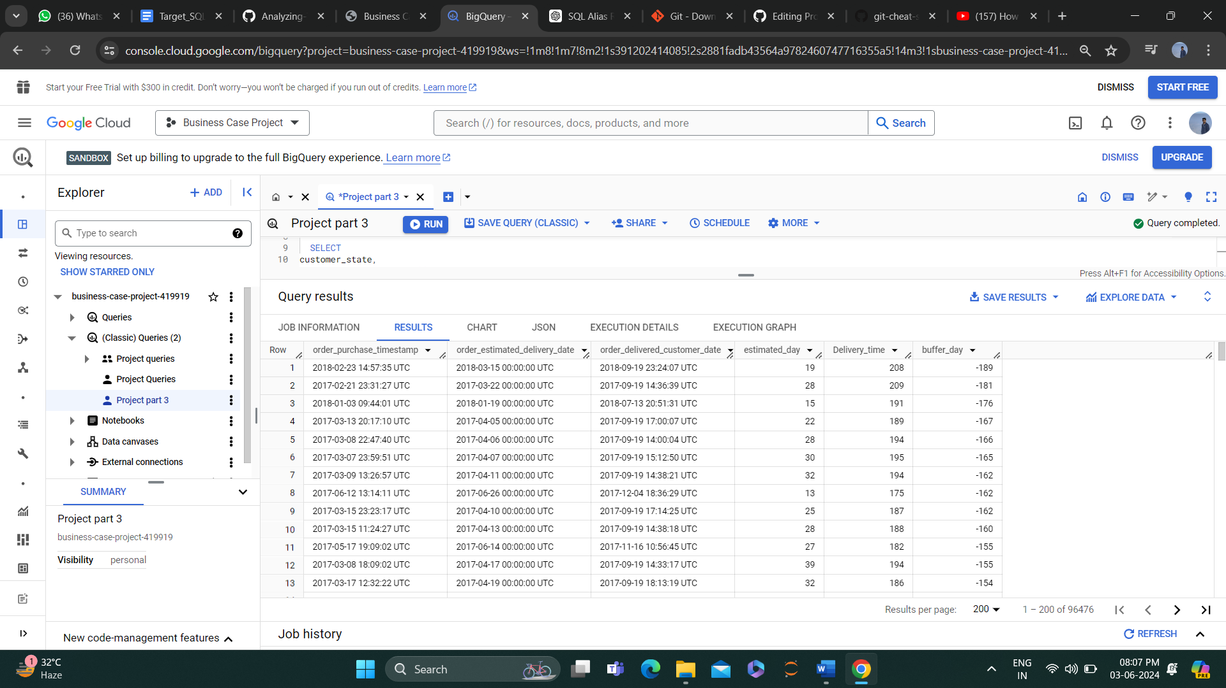

Insights -  There is a late delivery of max 189 days and there are several orders having this late delivery.

Recommendation- We can analyse the reason for the late delivery and give the correct estimated_delivery_date to the customer.

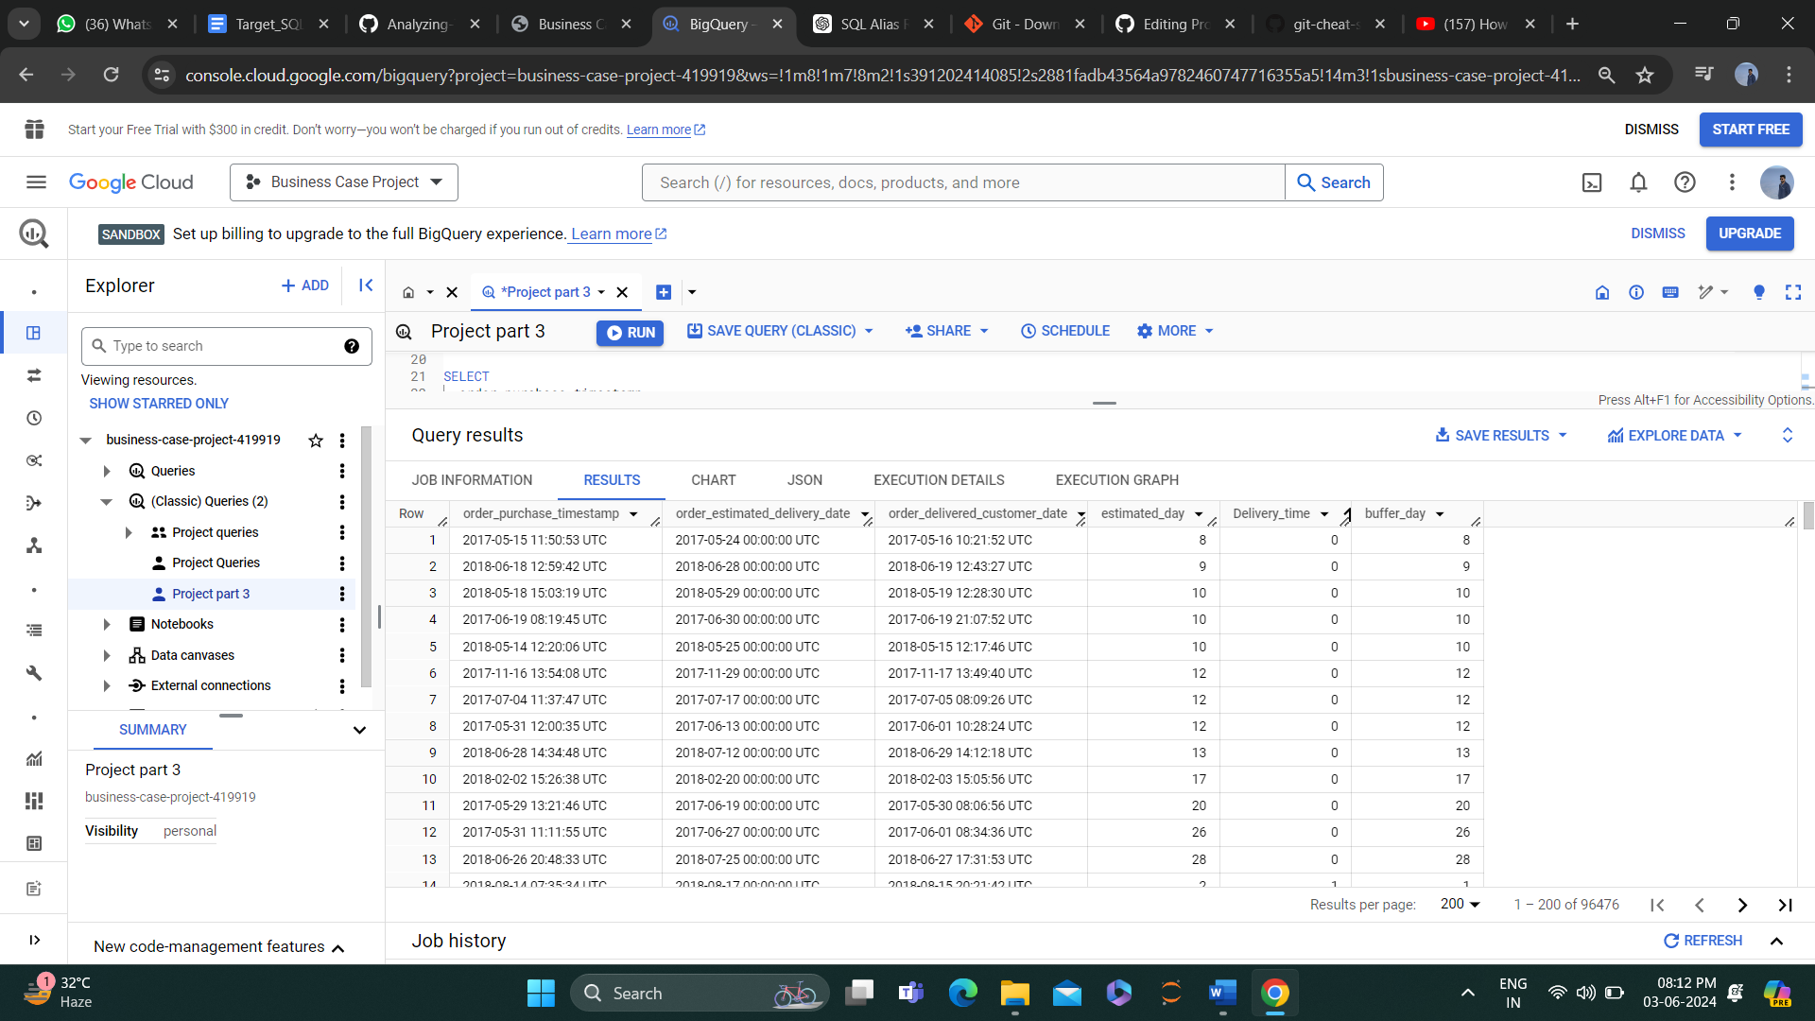

Insights 2 - After sorting data by Delivery_time we can see there is an order which is delivered on the same day or in 1 day.

Recommendation- We can encourage these customers to give good reviews on our online platform or in google my business.

**5.2. Top 5 states with highest/lowest average freight value - sort in desc/asc limit 5**

Query –

SELECT

     customer_state,

     AVG(freight_value) AS Avg_Freight FROM

     (SELECT

     customer_state,

     DATE_DIFF(order_delivered_customer_date, order_purchase_timestamp, DAY) AS time_to_delivery,

     DATE_DIFF(order_estimated_delivery_date, order_purchase_timestamp, DAY) AS diff_estimated_deliver,

     freight_value

     FROM

     `Project.Order_Items` AS items

     INNER JOIN

     `Project.Orders` AS o

     ON items.order_id = o.order_id

     INNER JOIN

     `Project.Customers` AS c

     ON o.customer_id = c.customer_id

     WHERE

     order_delivered_customer_date IS NOT NULL) GROUP BY customer_state

ORDER BY Avg_Freight DESC LIMIT 5;

Result –

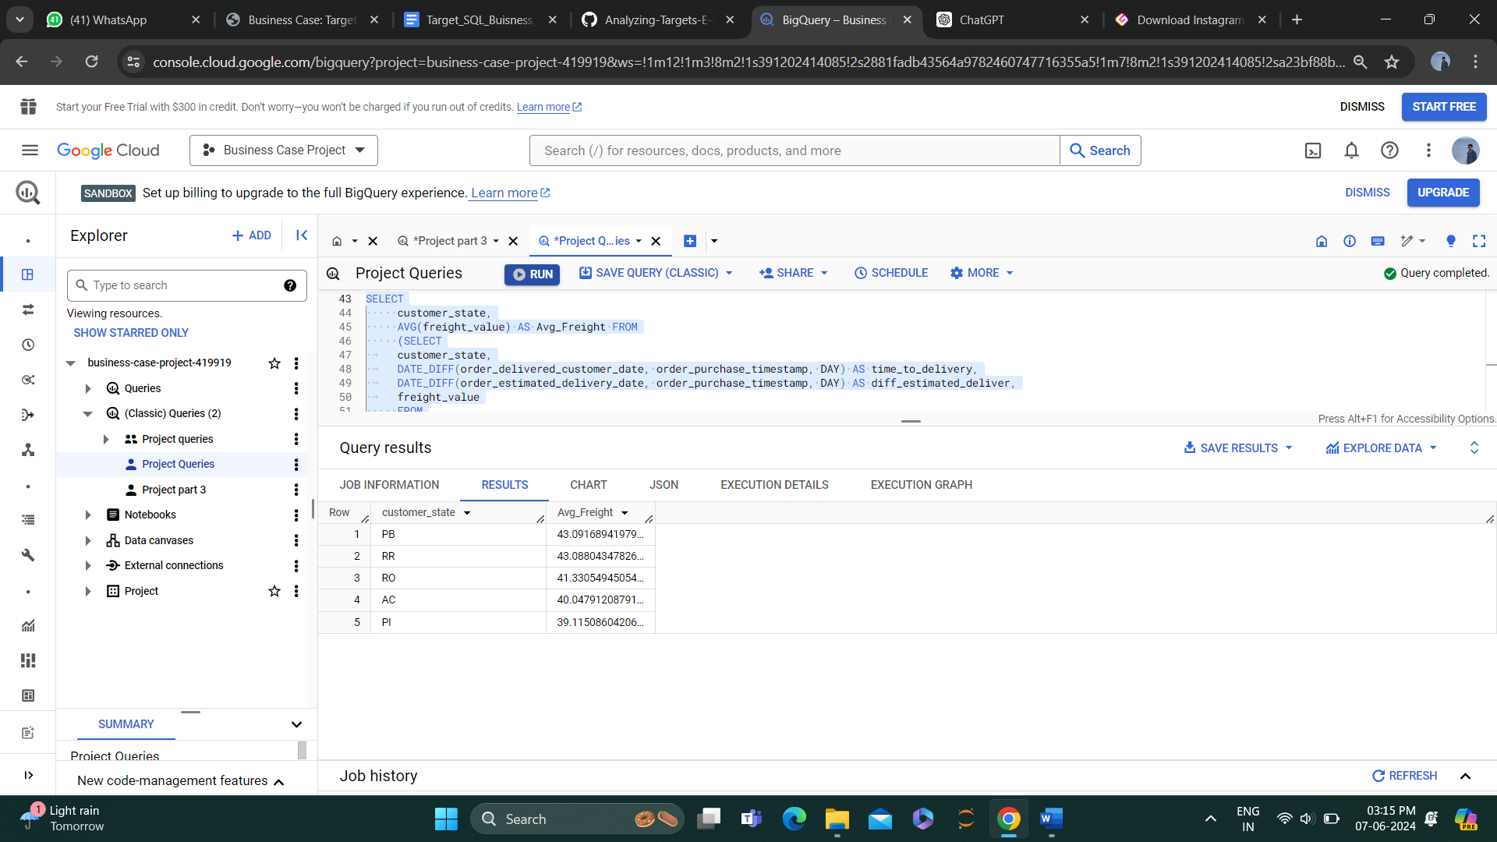

**5.3. Top 5 states with highest/lowest average time to delivery**

Query –

SELECT

customer_state,

AVG(time_to_delivery) AS Avg_time_to_delivery FROM

(SELECT

customer_state,

DATE_DIFF(order_delivered_customer_date, order_purchase_timestamp, DAY) AS time_to_delivery

FROM

`Project.Order_Items` AS items INNER JOIN

`Project.Orders` AS o ON

items.order_id = o.order_id INNER JOIN

`Project.Customers` AS c ON

o.customer_id = c.customer_id WHERE

order_delivered_customer_date IS NOT NULL) GROUP BY customer_state

ORDER BY Avg_time_to_delivery DESC LIMIT 5;

Result –

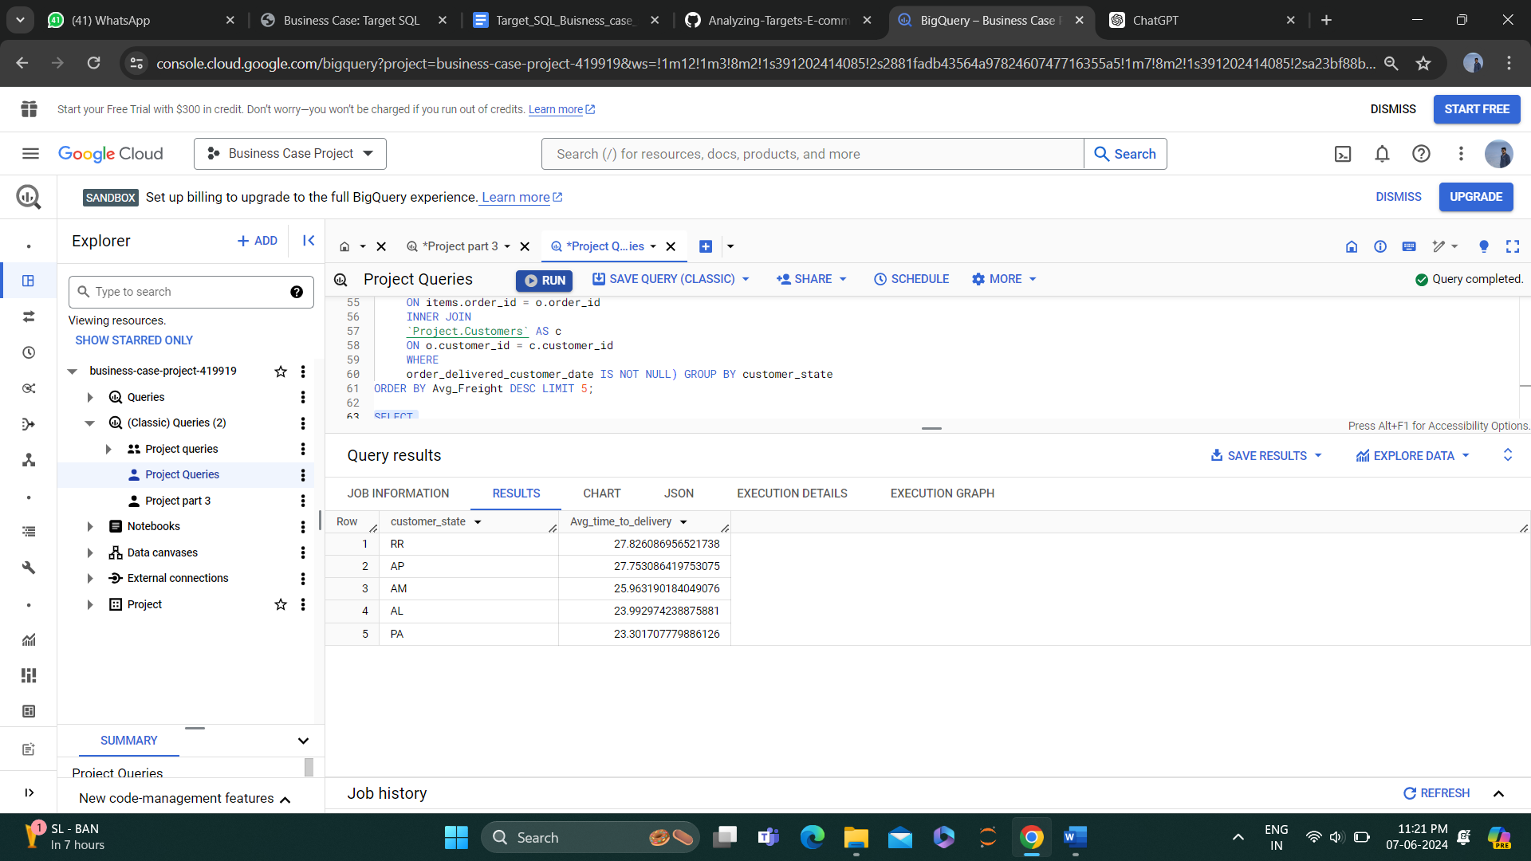

**5.4. Top 5 states where delivery is really fast/ not so fast compared to estimated date**

Query –

SELECT

customer_state,

AVG(diff_estimated_delivery) as diff_estimated_delivery FROM

(SELECT

customer_state, order_estimated_delivery_date, order_delivered_customer_date,

DATE_DIFF(order_estimated_delivery_date,order_delivered_customer_date , DAY) AS diff_estimated_delivery

FROM

`Project.Order_Items` AS items INNER JOIN

`Project.Orders` AS o ON

items.order_id = o.order_id INNER JOIN

`Project.Customers` AS c ON o.customer_id = c.customer_id

WHERE order_delivered_customer_date IS NOT NULL)

GROUP BY customer_state

ORDER BY diff_estimated_delivery ASC Limit 5;

Result –

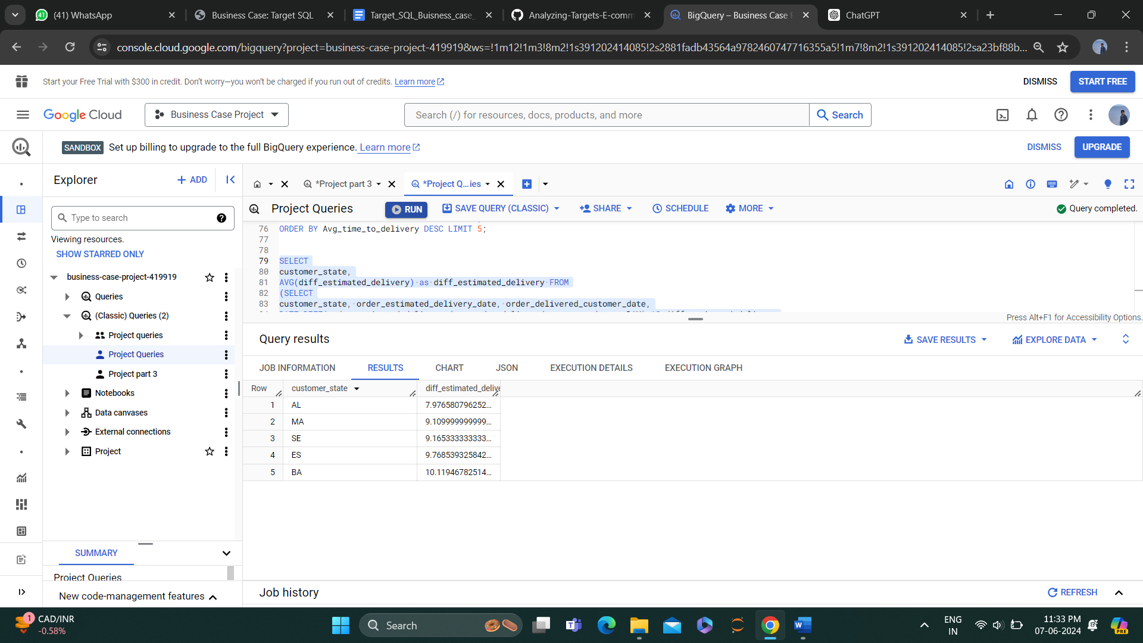

**6. Analysis based on the payments:**

6.1. Month on month number of orders placed using different payment types.

Query –

With Base as(SELECT Payment_type,

Month, Year,

count(distinct(order_id)) as Customer_count,

FROM (SELECT

o.customer_id, p.payment_type, o.order_id,

EXTRACT(Month from order_purchase_timestamp) As Month, EXTRACT(Year from order_purchase_timestamp) As Year

FROM `Project.Orders` AS o

LEFT JOIN `Project.Payments` AS p ON o.order_id = p.order_id)

GROUP BY payment_type, Month, Year ORDER BY Payment_type,Year,Month),

base2 as (Select *, Lag(Customer_count) over (PARTITION BY Payment_type order by Year,Month )as previous_Customer_count from base )

SELECT *, (Customer_count-previous_Customer_count)/previous_Customer_count*100 as per_INC from base2

Result –

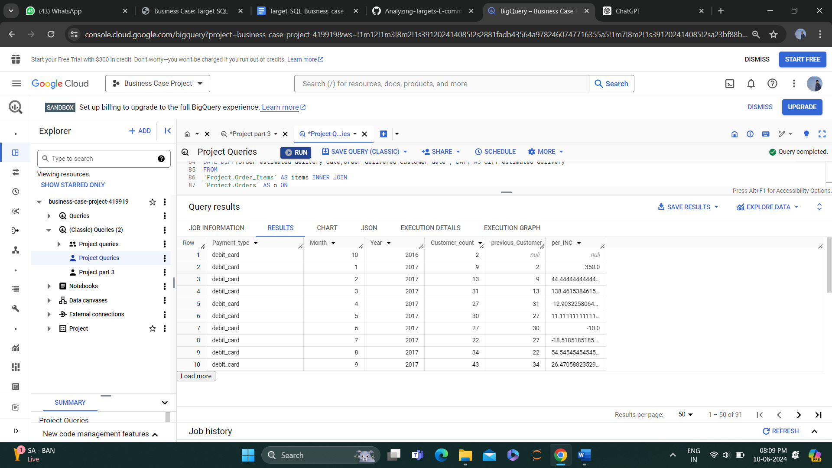

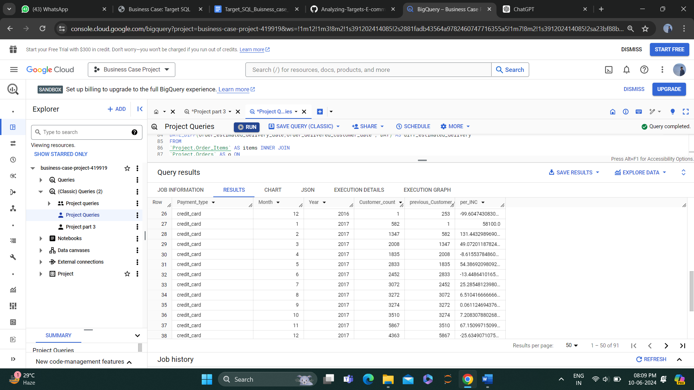

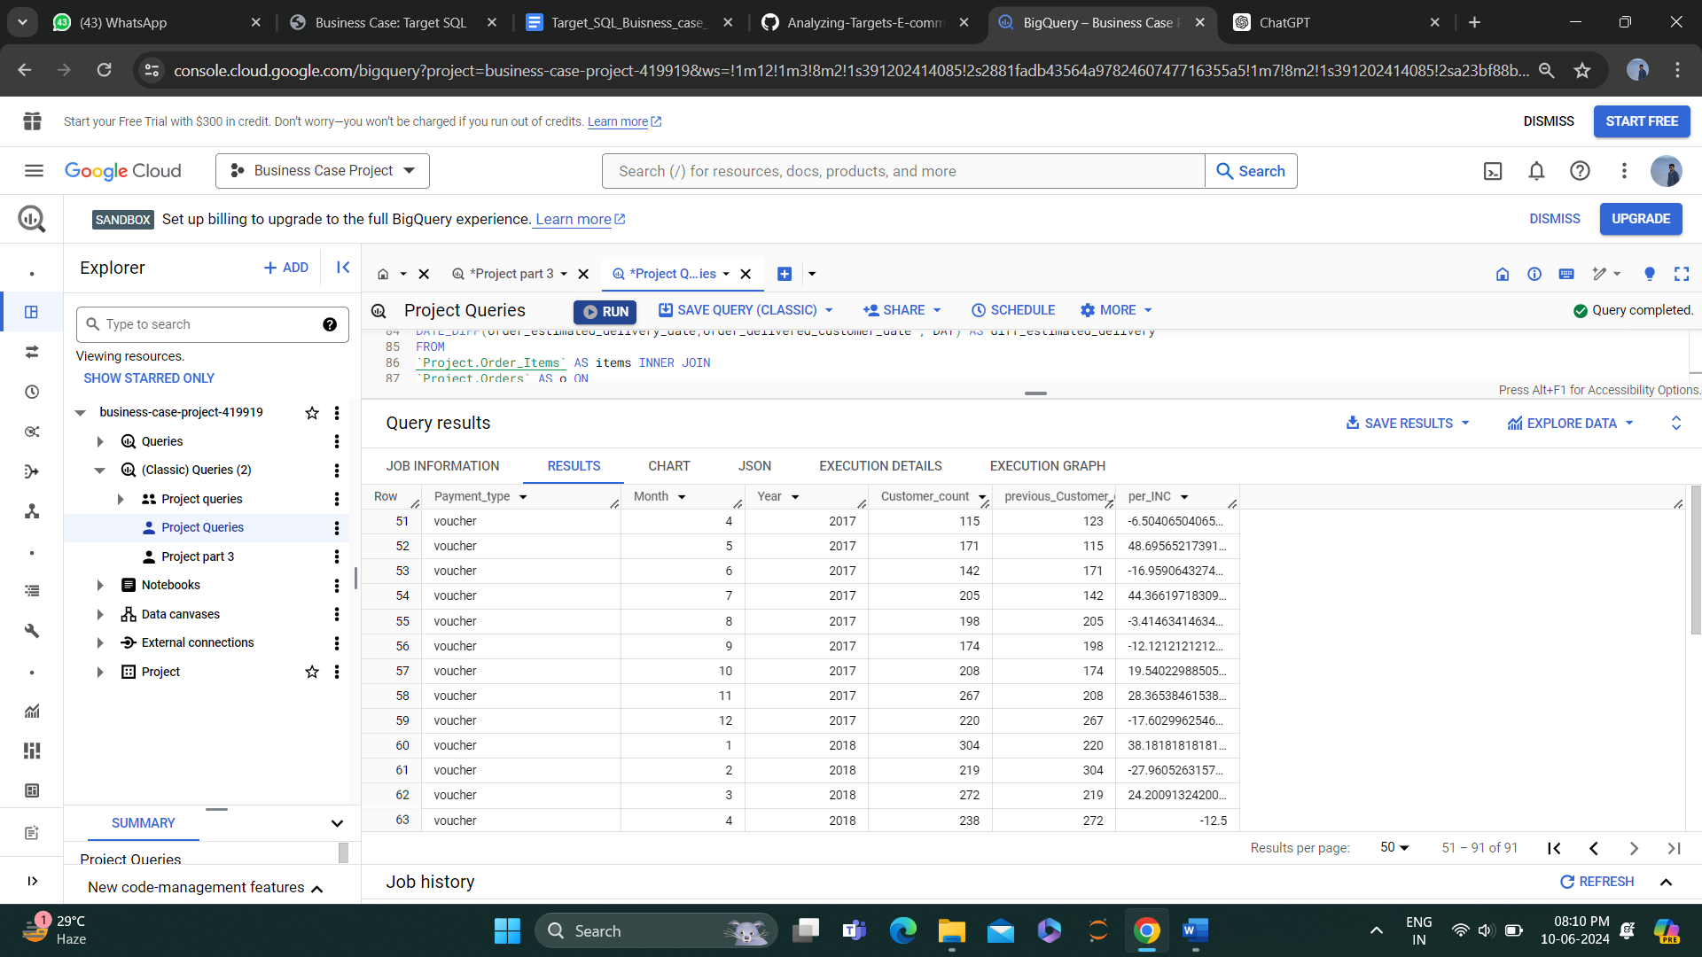

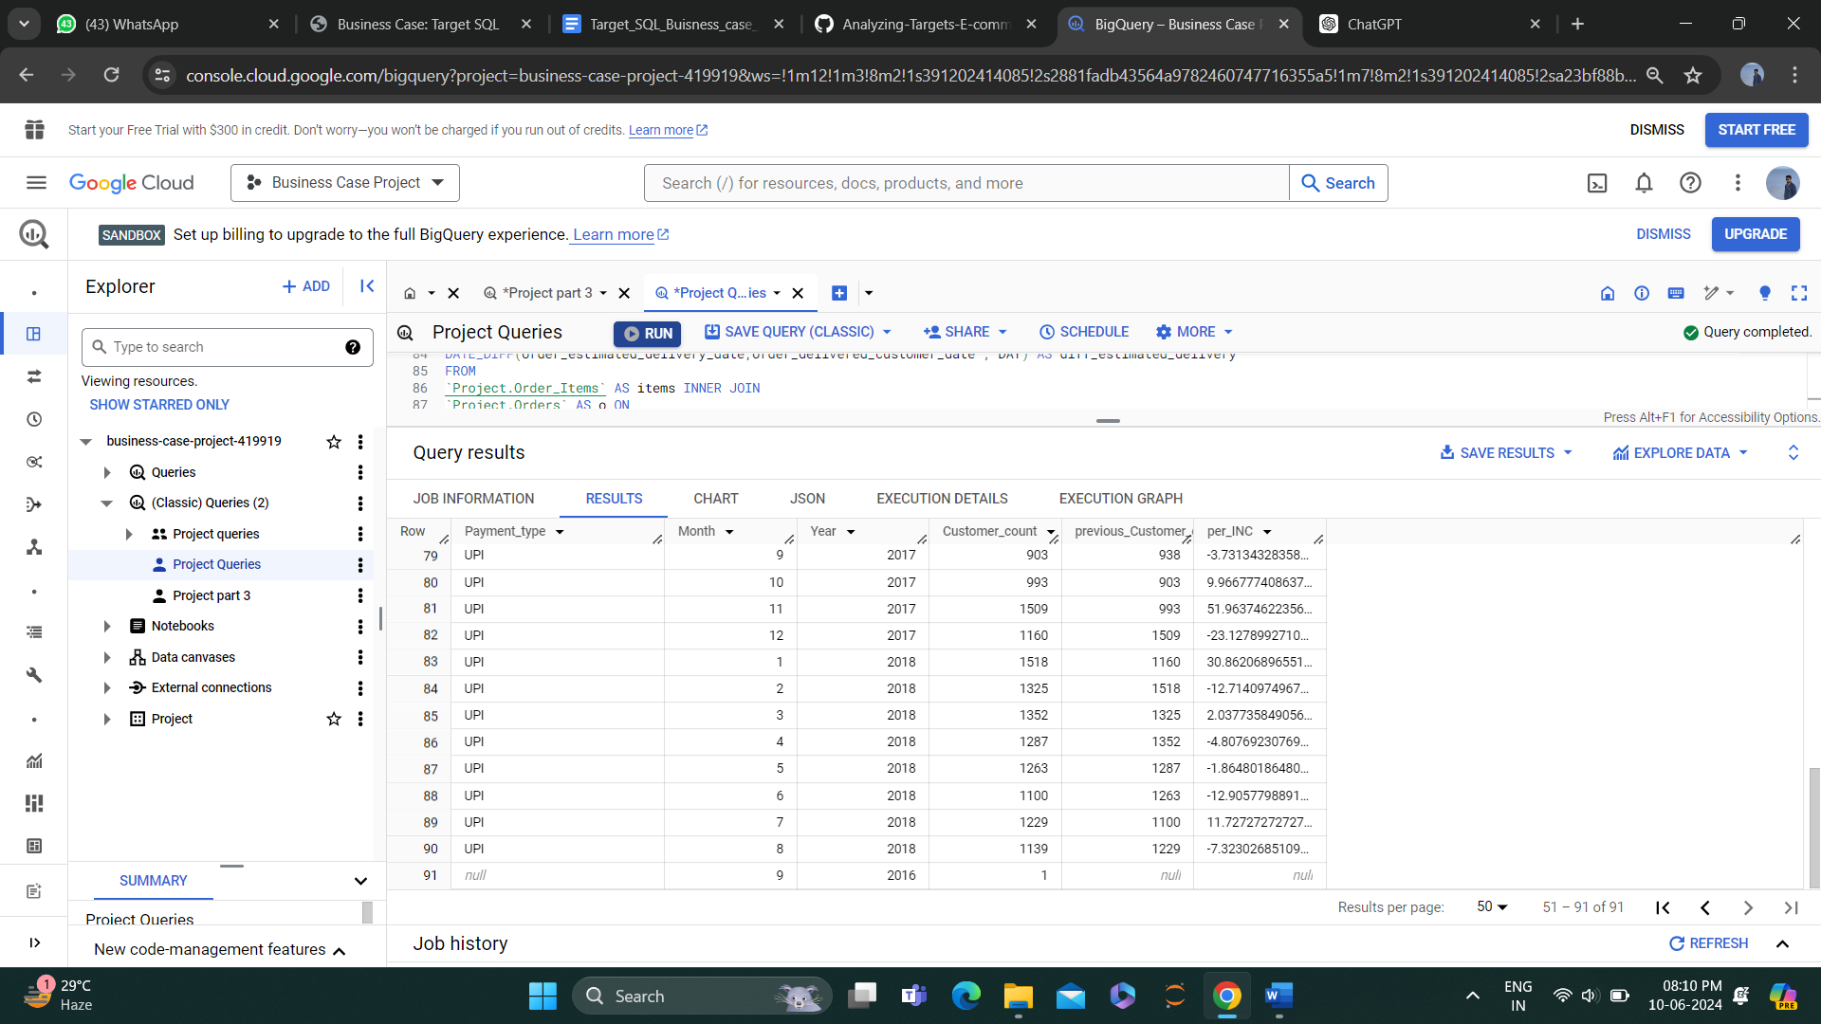

6.2. Orders placed on the basis of the payment instalments that have been paid.

Query –

Select payment_installments,

Count(distinct order_id) as order_count FROM

`Project.Payments`

group by payment_installments order by order_count Desc

Result –

